Currency Exchange

1. The currency exchange app should look like in the Figure 1:

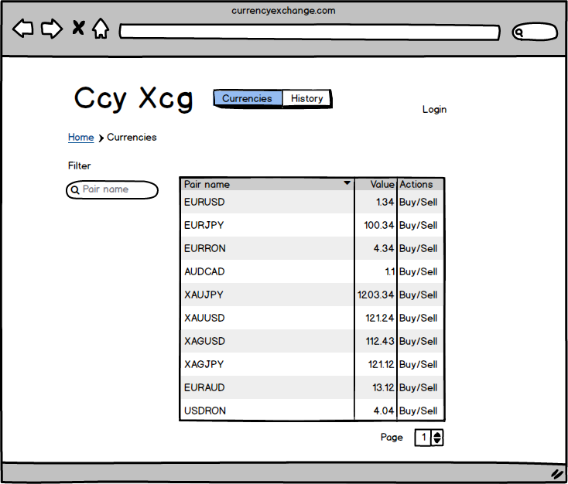

Figure 1

1. An admin user shall be created directly in the database with rights to create normal users. If the admin user is logged in a menu with options for adding normal users
2. When a normal user is logged in the History menu is enabled and the user can see currencies history and also buy currency pairs. If not logged in the History and Buy/Sell buttons are disabled.
3. The history tab is the one depicted in Figure 2. We give the user the possibility to select 2 currencies and for each of them see the history for last 30 days, 14 days, 7 days and 3 days.

The chart has time on the X axis and the Currency price on the Y axis.

1. Currency pairs are retrieved from a BNR feed and are overwritten to the database each 5 seconds. When the applications starts it will initialize itself with the last value of the currency pair. At the end of the day which is at an hour configured in the system a snapshot for all the currency pairs values will be written to a history table.

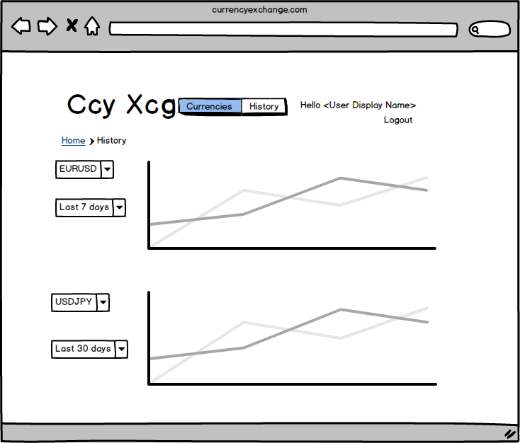

Figure

1. A CurrencyPair has the following properties: ID, PairSymbol, Description, LastReceivedValue, FirstCurrencyID, SecondCurrencyID
2. A Currency has the following properties: ID, Symbol, Description
3. An User has the following properties: ID, Username, Password, RealName, Email, Type, CurrencyID
4. An Account has properties: ID, UserID, Balance, CurrencyID
5. User can buy/sell only one currency pair at a time and when she sells/buys it back the account balance will be updated correspondingly.
6. User type can be Admin or User
7. The filter on the left allows filtering the currencies view by Pair name (symbol). The filtering will be triggered by key pressed.
8. The login button will allow a user to log in with his username and password and after successfull login it will display the User RealName and Logout button.
9. Technologies used:

* Java for the backend
* Apache Tomcat for the servlet container
* MySQL for the database
* JSP, HTML, CSS, Javascript for the frontend
* Git for version management